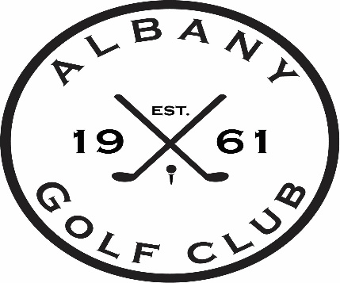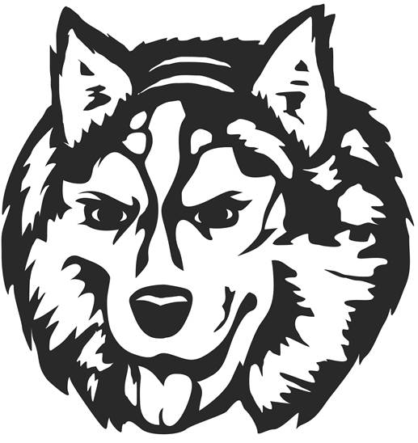

Jr Huskies Golf Camp 2023
Thursday June 15th, 22nd, & 29th
Thursday July 13th, 20th
Thursday July 27th – Contest Day
$90.00 per Jr Golfer
PAR GROUP (never golfed before, just starting ages:6-10)
8:00 lesson/8:15 on course or range/9:00 finish
BIRDIE GROUP (been through lessons before, understands the basics, been golfing on course ages: 9-12)
9:15 lesson/9:30 on course or range/10:15 finish
EAGLE GROUP (advanced golfer, understands etiquette, can golf on course alone 11-14)
10:30 lesson/10:45 on course or range/11:30 finish

*Mixed division for each group*
*limiting groups to maximum of 25 kids per, will adjust group if needed to allow maximum participation*

Name: ____________________________________________
Group: ____________________________________________
Age: ______________________________________________
Parents Name: ____________________________________
Contact Phone #: _________________________________
T-Shirt Size: ____________________________________
Payment Type (cash/check only)
Mail to:
Albany Golf Club
P.O. Box 338
Albany, MN 56307
If your Jr Golfer is carpooling or wants to be grouped with another Jr Golfer please fill out the bottom information line.
Please pair with: ___________________________________

