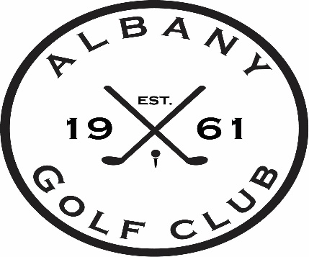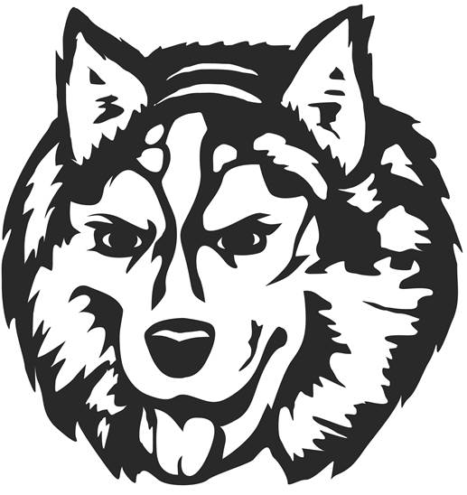

Jr Huskies Golf Camp 2022
Thursday June 16, 23rd, & 30th
Thursday July 14th & 21st
Thursday July 28th – Contest Day
$90.00 per Jr Golfer
(weekly prizes, Toptracer and course time, T-Shirt)
PAR GROUP (never golfed before, just starting)
8:00 lesson/8:15 on course or range/9:00 finish
BIRDIE GROUP (been through lessons before, understands the basics, been golfing on course)
9:15 lesson/9:30 on course or range/10:15 finish
EAGLE GROUP (advanced golfer, understands etiquette, can golf on course alone)
10:30 lesson/10:45 on course or range/11:30 finish

*Mixed division for each group*
*limiting groups to maximum of 25 kids per, will adjust group if needed to allow maximum participation*

Name: ____________________________________________
Group: ____________________________________________
Age: ______________________________________________
Parents Name: ____________________________________
Contact Phone #: _________________________________
T-Shirt Size: ____________________________________
Payment Type (cash/check only)
Mail to:
Albany Golf Club
P.O. Box 338
Albany, MN 56307
If your Jr Golfer is carpooling or wants to be grouped with another Jr Golfer please fill out the bottom information line.
Please pair with: ___________________________________

