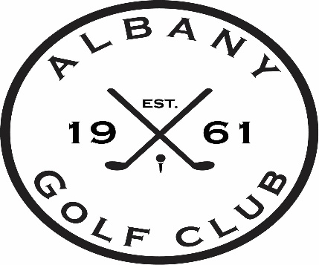

***Jr. Golf Camps 2025***

***Camp #1 June 9 – June 13***

***OR***

***Camp #2 July 14 – July 18***

***$110.00 per Jr Golfer***

**PAR GROUP** beginner, ages 6-9

8:00am – 9:15am

**BIRDIE GROUP** ages 9-12

9:15am – 10:15am

**EAGLE GROUP** ages 11-14

10:15am – 11:30am

Limit of 12 students per group

Each day a new skill will be taught along with various golf information, with Friday being the contest day. Each participant will receive an Adidas or Under Armour hat and a sleeve of golf balls.